Scheduling Algorithms:
A Process Scheduler schedules different processes to be assigned to the CPU based on particular scheduling algorithms. There are six popular process scheduling algorithms which we are going to discuss in this chapter −
- First-Come, First-Served (FCFS) Scheduling
- Shortest-Job-Next (SJN) Scheduling
- Priority Scheduling
- Shortest Remaining Time
- Round Robin(RR) Scheduling
- Multiple-Level Queues Scheduling.
These algorithms are either non-preemptive or preemptive.

First Come First Serve (FCFS) Algorithm:
- Jobs are executed on first come, first serve basis.
- It is a non-preemptive, pre-emptive scheduling algorithm.
- Easy to understand and implement.
- Its implementation is based on FIFO queue.
- Poor in performance as average wait time is high.
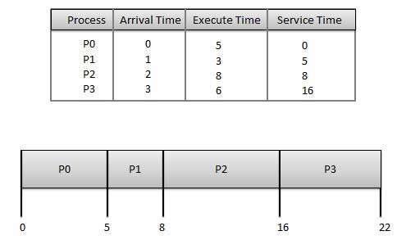

Wait time of each process is as follows –
Process | Wait Time : Service Time - Arrival Time
P0 | 0 - 0 = 0
P1 | 5 - 1 = 4
P2 | 8 - 2 = 6
P3 | 16 - 3 = 13

Average Wait Time: (0+4+6+13) / 4 = 5.75.

Priority Based Scheduling Algorithm:
- Priority scheduling is a non-preemptive algorithm and one of the most common scheduling algorithms in batch systems.
- Each process is assigned a priority. Process with highest priority is to be executed first and so on.
- Processes with same priority are executed on first come first served basis.
- Priority can be decided based on memory requirements, time requirements or any other resource requirement.
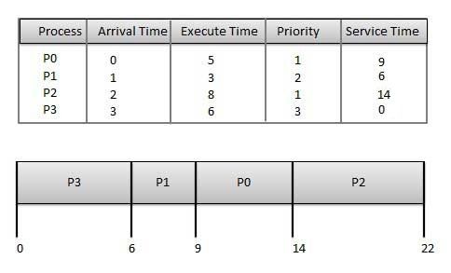
Wait time of each process is as follows –
Process | Wait Time : Service Time - Arrival Time
P0 | 9 - 0 = 9
P1 | 6 - 1 = 5
P2 | 14 - 2 = 12
P3 | 0 - 0 = 0

Average Wait Time: (9+5+12+0) / 4 = 6.5
Round Robin Scheduling Algorithm:
- Round Robin is the preemptive process scheduling algorithm.
- Each process is provided a fix time to execute, it is called a quantum.
- Once a process is executed for a given time period, it is preempted and other process executes for a given time period.
- Context switching is used to save states of preempted processes
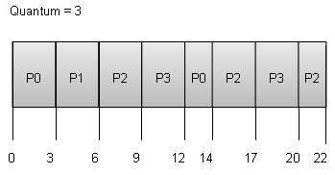

Wait time of each process is as follows −

Average Wait Time: (9+2+12+11) / 4 = 8.5
Process | Wait Time : Service Time - Arrival Time
P0 | (0 - 0) + (12 - 3) = 9
P1 | (3 - 1) = 2
P2 | (6 - 2) + (14 - 9) + (20 - 17) = 12
P3 | (9 - 3) + (17 - 12) = 11
Multiple-Level Queues Scheduling Algorithm:
Multiple-level queues are not an independent scheduling algorithm. They make use of other existing algorithms to group and schedule jobs with common characteristics.
- Multiple queues are maintained for processes with common characteristics.
- Each queue can have its own scheduling algorithms.
- Priorities are assigned to each queue.
For example, CPU-bound jobs can be scheduled in one queue and all I/O-bound jobs in another queue. The Process Scheduler then alternately selects jobs from each queue and assigns them to the CPU based on the algorithm assigned to the queue.

Another component that is involved in the CPU-scheduling function is the dispatcher, which is the module that gives control of the CPU to the process selected by the short-term scheduler. It receives control in kernel mode as the result of an interrupt or system call. The functions of a dispatcher involve the following:
- Context switches, in which the dispatcher saves the state (also known as context) of the process or thread that was previously running; the dispatcher then loads the initial or previously saved state of the new process.
- Switching to user mode.
- Jumping to the proper location in the user program to restart that program indicated by its new state.
The dispatcher should be as fast as possible, since it is invoked during every process switch. During the context switches, the processor is virtually idle for a fraction of time, thus unnecessary context switches should be avoided. The time it takes for the dispatcher to stop one process and start another is known as the dispatch latency
Scheduling disciplines:
Scheduling disciplines are algorithms used for distributing resources among parties which simultaneously and asynchronously request them. Scheduling disciplines are used in routers (to handle packet traffic) as well as in operating systems (to share CPU time among both threads and processes), disk drives (I/O scheduling), printers (print spooler), most embedded systems, etc.
The main purposes of scheduling algorithms are to minimize resource starvation and to ensure fairness amongst the parties utilizing the resources. Scheduling deals with the problem of deciding which of the outstanding requests is to be allocated resources. There are many different scheduling algorithms. In this section, we introduce several of them.
In packet-switched computer networks and other statistical multiplexing, the notion of a scheduling algorithm is used as an alternative to first-come first-served queuing of data packets.
The simplest best-effort scheduling algorithms are round-robin, fair queuing (a max-min fair scheduling algorithm), proportionally fair scheduling and maximum throughput. If differentiated or guaranteed quality of service is offered, as opposed to best-effort communication, weighted fair queuing may be utilized.
In advanced packet radio wireless networks such as HSDPA (High-Speed Downlink Packet Access ) 3.5G cellular system, channel-dependent scheduling may be used to take advantage of channel state information. If the channel conditions are favourable, the throughput and system spectral efficiency may be increased. In even more advanced systems such as LTE, the scheduling is combined by channel-dependent packet-by-packet dynamic channel allocation, or by assigning OFDMA multi-carriers or other frequency-domain equalization components to the users that best can utilize them.

Scheduling Criteria:
- There are several different criteria to consider when trying to select the "best" scheduling algorithm for a particular situation and environment, including:
  - CPU utilization - Ideally the CPU would be busy 100% of the time, so as to waste 0 CPU cycles. On a real system CPU usage should range from 40% (lightly loaded) to 90% (heavily loaded. )
  - Throughput - Number of processes completed per unit time. May range from 10 / second to 1 / hour depending on the specific processes.
  - Turnaround time - Time required for a particular process to complete, from submission time to completion. (Wall clock time.)
  - Waiting time - How much time processes spend in the ready queue waiting their turn to get on the CPU.
    - ( Load average - The average number of processes sitting in the ready queue waiting their turn to get into the CPU. Reported in 1-minute, 5-minute, and 15-minute averages by "uptime" and "who". )
  - Response time - The time taken in an interactive program from the issuance of a command to the commence of a response to that command.
- In general one wants to optimize the average value of a criteria ( Maximize CPU utilization and throughput, and minimize all the others. ) However some times one wants to do something different, such as to minimize the maximum response time.

- Sometimes it is most desirable to minimize the variance of a criteria than the actual value. I.e. users are more accepting of a consistent predictable system than an inconsistent one, even if it is a little bit slower.

Text Books:

1.Abraham Silberschatz, Peter B. Galvin, Greg Gagne, ―Operating System Principles‖, Wiley Student Edition, 8th Edition, 2010.
2.William Stallings, ―Operating System- Internals and Design Principles‖, Pearson Education, 6th Edition, 2002.

Reference Books:

1. Andrew S Tanenbaum, ―Modern Operating Systems‖, PHI, 3rd Edition, 2007.
2. D. M. Dhamdhere, ―Operating Systems a Concept based Approach‖, Tata McGraw-Hill, 2nd Edition, 2006.

